|  |
| --- |
| Batch Code: 1907C3 |

Curriculum code: 6740

**DREAMWEAVER E-PROJECT**

**WILSON SPORTING GOODS.COM**

**GROUP MEMBERS:**

* WAJAHAT MANSOORI
* YASIR SALEEM
* UBAIKA
* ANAS ANSARI

**SUBMITTED TO:**

[‘eprojects@aptech.ac.in](mailto:eprojects@aptech.ac.in)

**PROJECT INSTRUCTOR:**

**‘MS RABIYA AMIN’**

|  |
| --- |
| Batch Code: 1907C3 |

**DEVELOPER GUIDE**

**SYSTEM REQUIREMENT:**

|  |  |  |
| --- | --- | --- |
| **NO** | **ITEMS** | **DESCRIPTION** |
| 1. | **Operating system** | **Windows 7, Windows 8, Windows 10 etc** |
| 2. | **RAM (memory)** | **Minimum 64** |
| 3. | **Web browser** | **Chrome & Firefox** |
| 4. | **Software** | **Dreamweaver/ Visual Code** |

**HOME PAGE**

This website is about Sports products of different brands, which includes products related to men as well as for women.

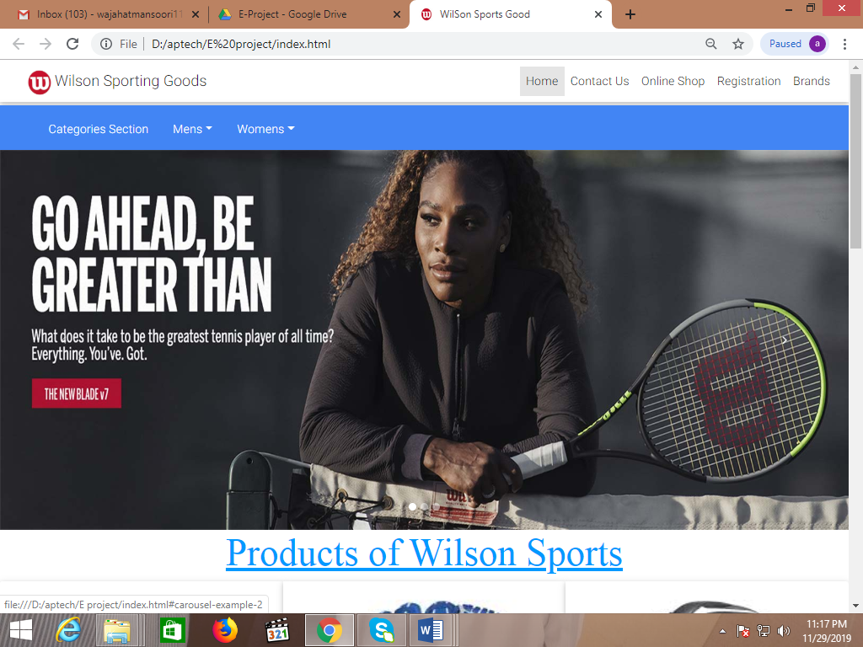

|  |
| --- |
| Batch Code: 1907C3 |

<nav class="navbar navbar-expand-lg navbar-light bg-">

<ul class="navbar-nav">

<li class="ml-3">

<img src="images/log3.jpg" width="40" height="35" class="img-responsive mt-1">

</li>

</ul>

<a class="navbar-brand" href="#">Wilson Sporting Goods</a>

<button class="navbar-toggler" type="button" data-toggle="collapse" data-target="#navbarNav" aria-controls="navbarNav" aria-expanded="false" aria-label="Toggle navigation">

<span class="navbar-toggler-icon"></span>

</button>

<div class="collapse navbar-collapse" id="navbarNav">

<ul class="navbar-nav ml-auto ">

<li class="nav-item active">

<a class="nav-link" href="index.html">Home </a>

</li>

<!-- Collapse button -->

<button class="navbar-toggler" type="button" data-toggle="collapse" data-target="#basicExampleNav"

aria-controls="basicExampleNav" aria-expanded="false" aria-label="Toggle navigation">

<span class="navbar-toggler-icon"></span>

</button>

|  |
| --- |
| Batch Code: 1907C3 |

**Contact Us**

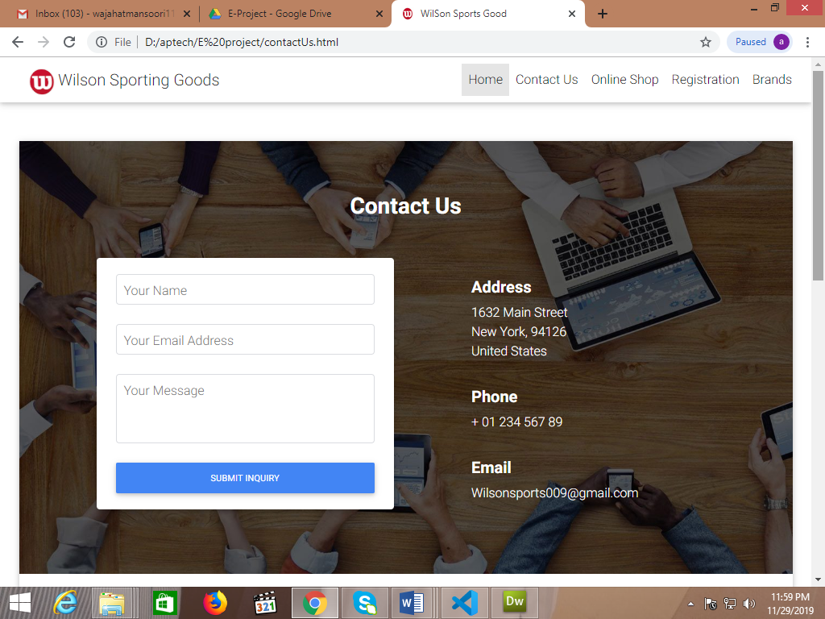

|  |
| --- |
| Batch Code: 1907C3 |

<form class="mx-md-5" action="">

<div class="row">

<div class="col-md-6 mb-4">

<div class="card">

<div class="card-body px-4">

<!-- Name -->

<div class="md-form md-outline mt-0">

<input type="text" required pattern="^[A-Za-z]{1,32}$" id="name" class="form-control">

<label for="name">Your Name</label>

</div>

<!-- Email -->

<div class="md-form md-outline">

<input type="text" required pattern= "^[a-zA-Z0-9.!#$%&'*+/=?^_`{|}~-]+@[a-zA-Z0-9](?:[a-zA-Z0-9-]{0,61}[a-zA-Z0-9])?(?:\.[a-zA-Z0-9](?:[a-zA-Z0-9-]{0,61}[a-zA-Z0-9])?)*$"; id="email" class="form-control">

<label for="email">Your Email Address</label>

</div>

<!-- Message -->

<div class="md-form md-outline">

<textarea required id="message" class="md-textarea form-control" rows="3"></textarea>

<label for="message">Your Message</label>

</div>

<button type="submit" class="btn btn-primary btn-md btn-block ml-0 mb-0">Submit inquiry</button>

</div>

|  |
| --- |
| Batch Code: 1907C3 |

**ONLINE SHOP**

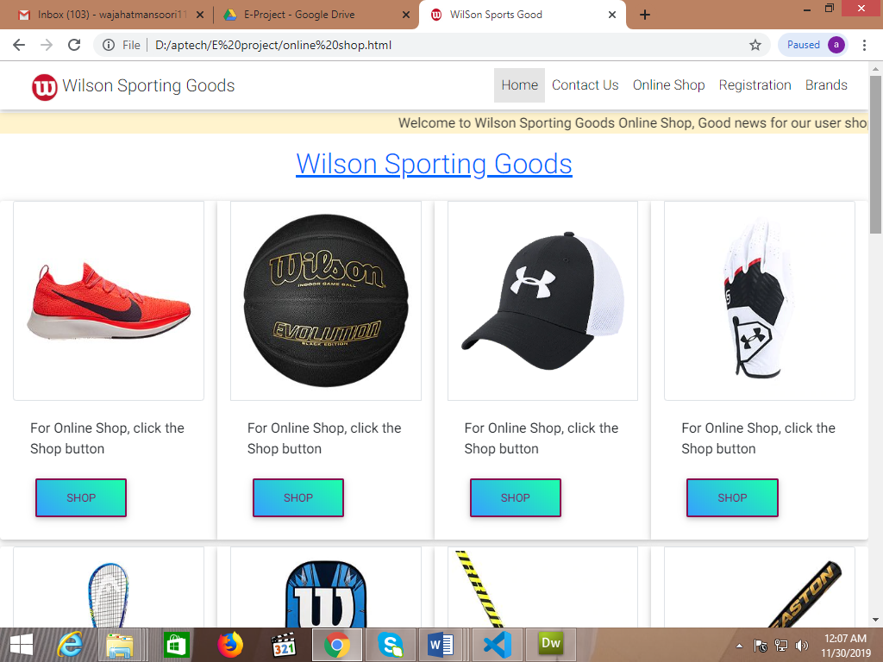

<div class="card-group mt-4">

<div class="card col-md-3 col-xs-6">

<img class="card-img-top img-thumbnail" src="images/Nike Shoes/nikeshoes01.jpg" alt="Card image cap">

<div class="card-body">

<p id="">For Online Shop, click the Shop button</p>

<a href="sports shoes cart.html" target="_blank" class="btn btn-outline-unique aqua-gradient-rgba" id="b1">Shop</a>

</div>

</div>

|  |
| --- |
| Batch Code: 1907C3 |

**REGISTRATION**

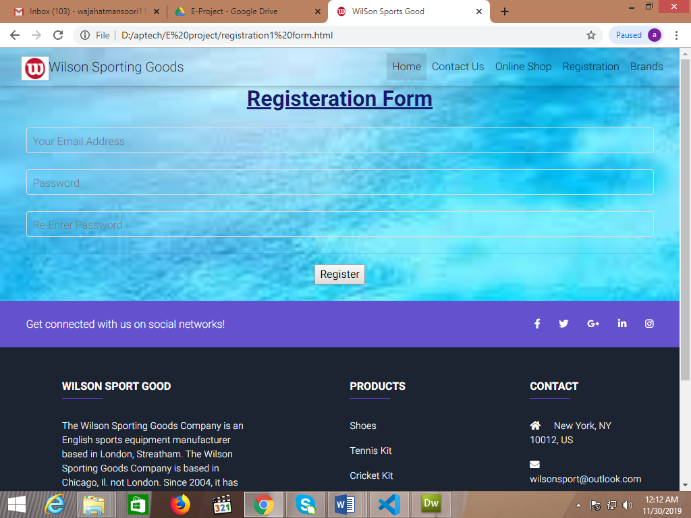

<form name="fm" action="">

<div class="container md-form md-outline mt-0">

<center>

<h1 class="h1-responsive" style="font-weight: bold; text-decoration: underline; color: midnightblue;">Registeration Form</h1>

<div class="md-form md-outline">

<input type="text" required pattern= "^[a-zA-Z0-9.!#$%&'*+/=?^_`{|}~-]+@[a-zA-Z0-9](?:[a-zA-Z0-9-]{0,61}[a-zA-Z0-9])?(?:\.[a-zA-Z0-9](?:[a-zA-Z0-9-]{0,61}[a-zA-Z0-9])?)*$"; id="email" class="form-control">

<label for="email">Your Email Address</label>

</div>

<div class="md-form md-outline">

<input type="text" name="ps" required pattern="^[A-Za-z0-9]{1,32}$"; minlength="8" id="email" class="form-control">

<label for="email">Password</label>

</div>

<div class="md-form md-outline">

<input type="text" name="ps2" required pattern="^[A-Za-z0-9]{1,32}$"; minlength="8" id="email" class="form-control">

<label for="email">Re-Enter Password</label>

</div>

<hr>

<button type="submit" onClick="registered()" >Register</button>

</div>

|  |
| --- |
| Batch Code: 1907C3 |

**FOOTER**

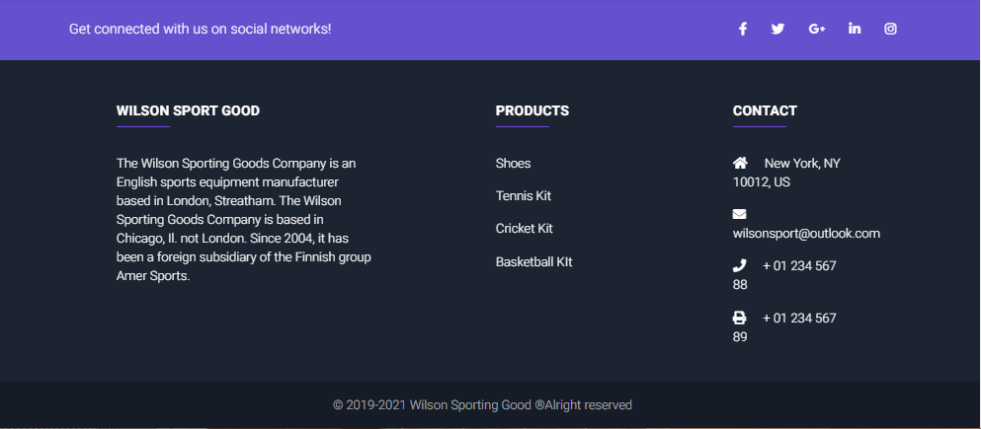

<footer class="page-footer font-small unique-color-dark">

<div style="background-color: #6351ce;">

<div class="container">

<!-- Grid row-->

<div class="row py-4 d-flex align-items-center mt-1">

<!-- Grid column -->

<div class="col-md-6 col-lg-5 text-center text-md-left mb-4 mb-md-0">

<h6 class="mb-0">Get connected with us on social networks!</h6>

</div>

<!-- Grid column -->

<!-- Grid column -->

<div class="col-md-6 col-lg-7 text-center text-md-right">

<!-- Facebook -->

<a class="fb-ic" href="https://www.facebook.com" target="_blank">

<i class="fab fa-facebook-f white-text mr-4"> </i>

</a>

<!-- Twitter -->

<a class="tw-ic" href="https://www.twitter.com" target="_blank">

<i class="fab fa-twitter white-text mr-4"> </i>

</a>

<!-- Google +-->

<a class="gplus-ic" href="https://www.google.com" target="_blank">

<i class="fab fa-google-plus-g white-text mr-4"> </i>

</a>

<!--Linkedin -->

<a class="li-ic" href="https://www.linkedin.com" target="_blank">

<i class="fab fa-linkedin-in white-text mr-4"> </i>

</a>

<!--Instagram-->

<a class="ins-ic" href="https://www.instagram.com" target="_blank">

<i class="fab fa-instagram white-text"> </i>

</a>

</div>

<!-- Grid column -->

</div>

<!-- Grid row-->

</div>

</div>

|  |
| --- |
| Batch Code: 1907C3 |

<!-- Facebook -->

<a class="fb-ic" href="https://www.facebook.com" target="_blank">

<i class="fab fa-facebook-f white-text mr-4"> </i>

</a>

<!-- Twitter -->

<a class="tw-ic" href="https://www.twitter.com" target="_blank">

<i class="fab fa-twitter white-text mr-4"> </i>

</a>

<!-- Google +-->

<a class="gplus-ic" href="https://www.google.com" target="_blank">

<i class="fab fa-google-plus-g white-text mr-4"> </i>

</a>

<!--Linkedin -->

<a class="li-ic" href="https://www.linkedin.com" target="_blank">

<i class="fab fa-linkedin-in white-text mr-4"> </i>

</a>

<!--Instagram-->

<a class="ins-ic" href="https://www.instagram.com" target="_blank">

<i class="fab fa-instagram white-text"> </i>

</a>

</div>

<!-- Grid column -->

</div>

<!-- Grid row-->

</div>

</div>